Point Outside a Solid

Definition
# Source: AI Source: Provided by: [Data Path: Persons Table -> ID Column: 1, Name_En Column: Motasem Essam] -> From: [ChatGPT] on [7/25/2026]
A point outside a solid is a point whose position lies in the exterior of a three-dimensional solid, excluding both its interior and its boundary.
A point in three-dimensional space is represented by coordinates $\left(x,y,z\right)$. Whether the point is outside a solid depends on the equations and inequalities defining that solid.
For example, a point $P\left(x,y,z\right)$ lies outside a sphere centered at the origin with radius $r$ if
$$x^{2}+y^{2}+z^{2}>r^{2}$$
The strict inequality indicates that the point is farther from the center than the sphere's radius.

Simple Definition
# Source: AI Source: Provided by: [Data Path: Persons Table -> ID Column: 1, Name_En Column: Motasem Essam] -> From: [ChatGPT] on [7/25/2026]
A point outside a solid is a point located beyond the outer boundary of a three-dimensional object, such as a point outside a cube, sphere, cylinder, or pyramid.
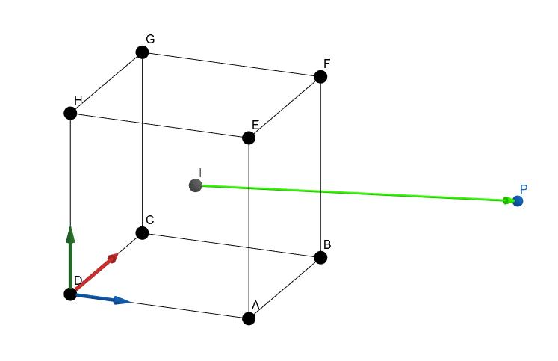

Key Characteristics
# Source: AI Source: Provided by: [Data Path: Persons Table -> ID Column: 1, Name_En Column: Motasem Essam] -> From: [ChatGPT] on [7/25/2026]
- Three-dimensional location: Represented by coordinates $\left(x,y,z\right)$.
- Zero-dimensional: A point has no length, width, or height.
- Exterior position: It does not belong to the solid's interior or boundary.
- Shape-dependent conditions: Its position is determined using the geometric definition of the solid.
- Positive distance from the solid: For a closed solid, an exterior point has a positive minimum distance from the solid.
- Unlimited possible locations: A point may be near the surface or very far away and still be outside.

Types of Points Outside Solids

1. Point Outside a Polyhedron
# Source: AI Source: Provided by: [Data Path: Persons Table -> ID Column: 1, Name_En Column: Motasem Essam] -> From: [ChatGPT] on [7/25/2026]
A polyhedron is a solid bounded by flat polygonal faces, such as a cube, cuboid, prism, or pyramid.
Consider a cube occupying the region
$$0≤x,y,z≤4$$
The point $P\left(5,2,2\right)$ lies outside because its $x$-coordinate exceeds the cube's maximum $x$-coordinate.
Examples:
- A point outside a cube.
- A point outside a rectangular cuboid.
- A point outside a triangular prism.
- A point outside a pyramid.

2. Point Outside a Solid with Curved Surfaces
# Source: AI Source: Provided by: [Data Path: Persons Table -> ID Column: 1, Name_En Column: Motasem Essam] -> From: [ChatGPT] on [7/25/2026]
A solid with curved surfaces includes spheres, cylinders, cones, and ellipsoids.
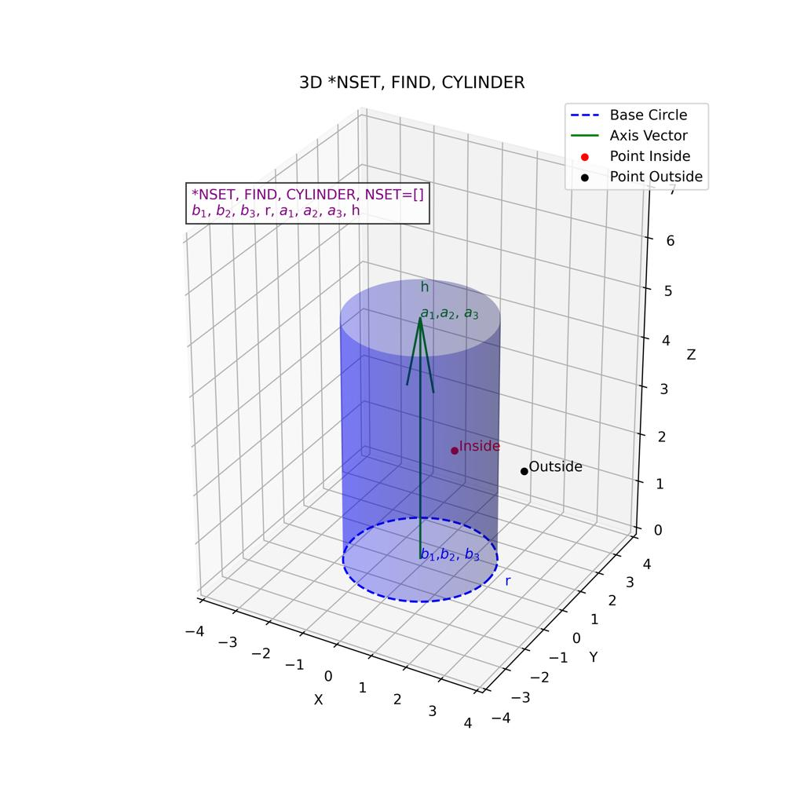
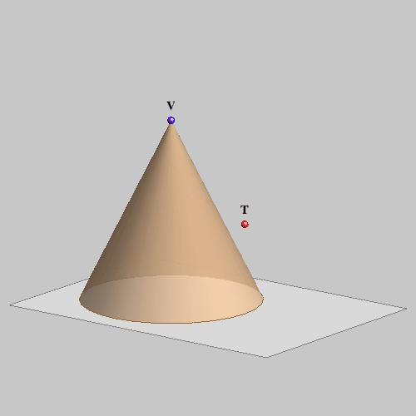
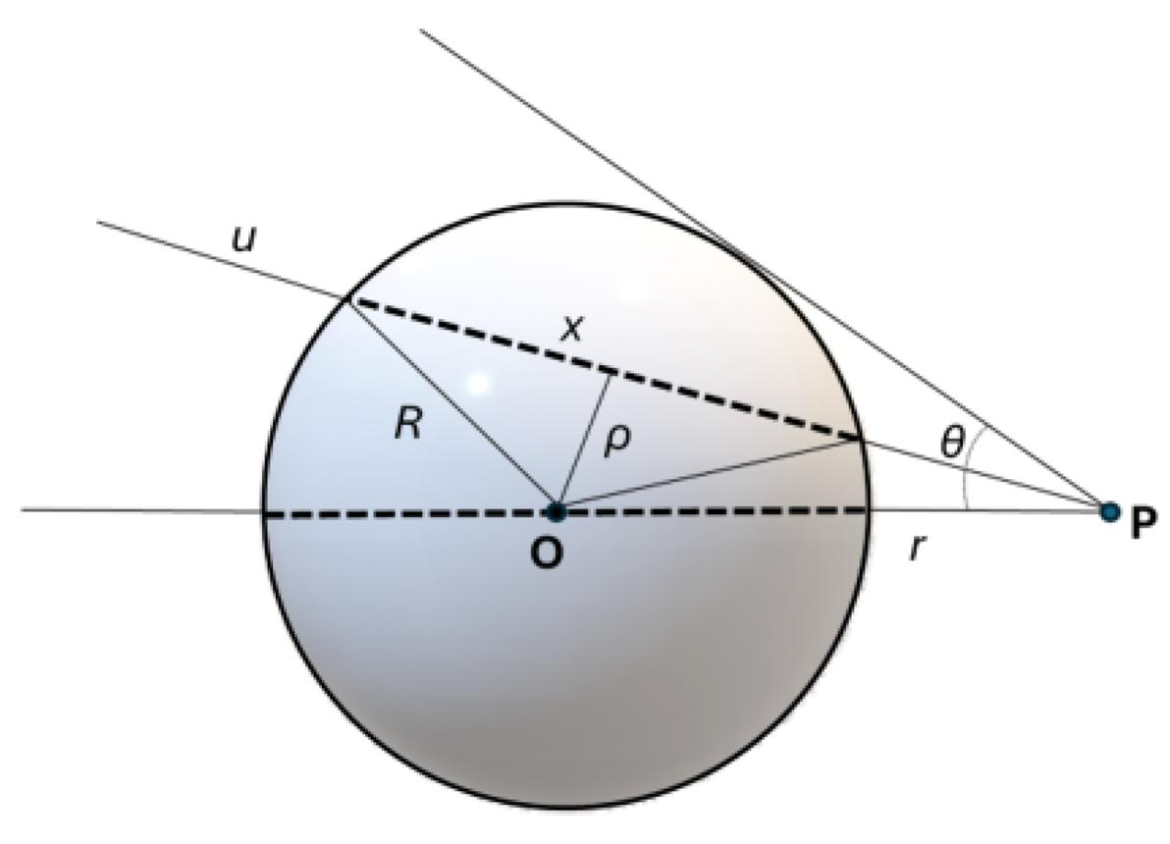
For a sphere centered at the origin with radius $r$, a point $P\left(x,y,z\right)$ lies outside if
$$x^{2}+y^{2}+z^{2}>r^{2}$$
For a right circular cylinder centered on the $z$-axis, with radius $r$ and height from $z=0$ to $z=h$, a point is outside if it fails the conditions for being inside or on the cylinder's boundary. For example, any point satisfying
$$x^{2}+y^{2}>r^{2}$$
is outside the cylinder's curved side region, regardless of its height.
Examples:
- A point outside a sphere.
- A point beyond the curved side of a cylinder.
- A point beyond a cone's surface.
- A point outside an ellipsoid.

3. Point Outside a Composite Solid
# Source: AI Source: Provided by: [Data Path: Persons Table -> ID Column: 1, Name_En Column: Motasem Essam] -> From: [ChatGPT] on [7/25/2026]
A composite solid is formed by combining two or more simple solids.
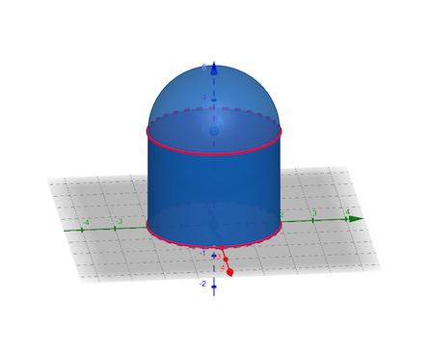
A point is outside a composite solid when it does not belong to the interior or external boundary of the combined object.
For example, if a hemisphere is joined to a cylinder, a point beyond the exposed curved surface of the hemisphere may lie outside the entire combined solid.
Important: A point outside one component is not necessarily outside the composite solid. It may lie inside another component that forms part of the combined object.

4. Point Beyond a Face's Plane
# Source: AI Source: Provided by: [Data Path: Persons Table -> ID Column: 1, Name_En Column: Motasem Essam] -> From: [ChatGPT] on [7/25/2026]
A point can lie beyond the plane containing a face of a solid.
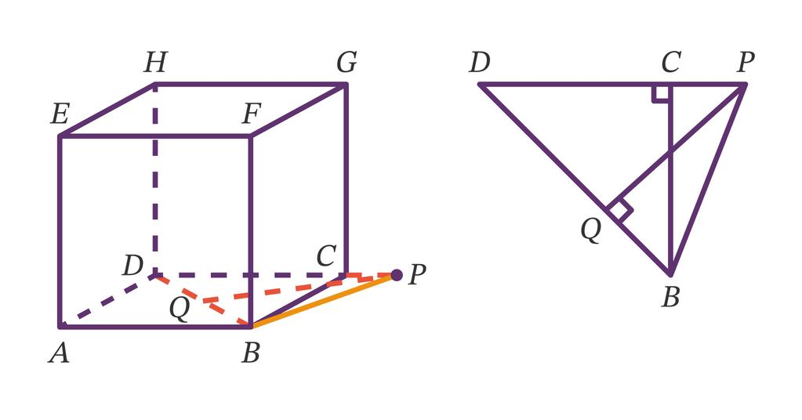
For a cube occupying $0≤x,y,z≤4$, the plane of its right face is
$$x=4$$
The point $P\left(5,2,2\right)$ is beyond this plane on the side where $x>4$, so it is outside the cube.
However, being beyond the plane of just one face does not always mean being outside a general solid. A point can be beyond one face's plane while still lying within the half-spaces defined by other faces. The complete solid's conditions must be checked.

5. Point Far from a Solid
# Source: AI Source: Provided by: [Data Path: Persons Table -> ID Column: 1, Name_En Column: Motasem Essam] -> From: [ChatGPT] on [7/25/2026]
A point may be located far away from a solid and remain outside it. Distance from a solid is measured using the shortest distance between the point and any point in the solid.
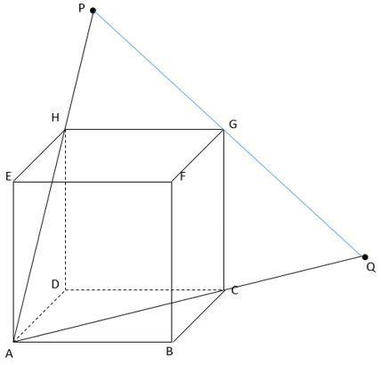
For example, if a cube occupies $0≤x,y,z≤2$, then $P\left(10,10,10\right)$ is outside it.
The point's distance from the cube is
$$D=\sqrt{{\left(10-2\right)}^{2}+{\left(10-2\right)}^{2}+{\left(10-2\right)}^{2}}$$
$$D=8\sqrt{3}$$
The closest point on the cube is the vertex $\left(2,2,2\right)$.

Mathematical Representation

1. General condition
# Source: AI Source: Provided by: [Data Path: Persons Table -> ID Column: 1, Name_En Column: Motasem Essam] -> From: [ChatGPT] on [7/25/2026]
Let $S$ be a solid and $∂S$ its boundary. A point $P$ is outside the solid when
$$P∉S$$
For a closed solid, this excludes both its interior and boundary.

2. Examples of outside conditions
# Source: AI Source: Provided by: [Data Path: Persons Table -> ID Column: 1, Name_En Column: Motasem Essam] -> From: [ChatGPT] on [7/25/2026]
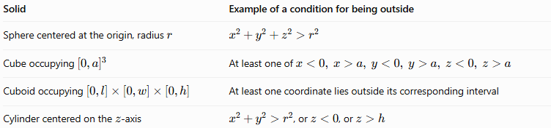
Solid | Example of a condition for being outside
Sphere centered at the origin, radius $r$ | $$x^{2}+y^{2}+z^{2}>r^{2}$$
Cube occupying ${\left[0,a\right]}^{3}$ | At least one of $x<0, x>a, y<0, y>a, z<0, z>a$
Cuboid occupying $\left[0,l\right]×\left[0,w\right]×\left[0,h\right]$ | At least one coordinate lies outside its corresponding interval
Cylinder centered on the $z$-axis | $x^{2}+y^{2}>r^{2}$, or $z<0$, or $z>h$
For the cube and cuboid conditions, the intervals describe the entire closed solid, including its faces. For the cylinder, the listed conditions assume its radius is $r$ and its height extends from $z=0$ to $z=h$.

3. Comparing a point with a sphere
# Source: AI Source: Provided by: [Data Path: Persons Table -> ID Column: 1, Name_En Column: Motasem Essam] -> From: [ChatGPT] on [7/25/2026]
For a sphere centered at the origin with radius $r$, calculate
$$s=x^{2}+y^{2}+z^{2}$$
- If $s<r^{2}$, the point is inside.
- If $s=r^{2}$, the point is on the surface.
- If $s>r^{2}$, the point is outside.

Worked Examples
# Source: AI Source: Provided by: [Data Path: Persons Table -> ID Column: 1, Name_En Column: Motasem Essam] -> From: [ChatGPT] on [7/25/2026]
Example 1: Point outside a sphere
A sphere is centered at the origin and has radius $4$. Determine whether $P\left(4,3,0\right)$ is outside.
Calculate:
$$4^{2}+3^{2}+0^{2}=16+9=25$$
Since
$$25>4^{2}=16$$
Answer: $P\left(4,3,0\right)$ is outside the sphere.
Example 2: Point outside a cube
A cube occupies $0≤x,y,z≤5$. Determine whether $Q\left(6,2,3\right)$ is outside.
The $x$-coordinate is $6$, which exceeds the maximum allowed value of $5$.
Answer: $Q\left(6,2,3\right)$ is outside the cube.
Example 3: Point outside a cylinder
A cylinder has radius $3$, centered on the $z$-axis, and extends from $z=0$ to $z=6$. Determine whether $R\left(4,0,3\right)$ is outside.
Calculate:
$$x^{2}+y^{2}=4^{2}+0^{2}=16$$
Since $16>3^{2}=9$, the point lies beyond the cylinder's curved side.
Answer: $R\left(4,0,3\right)$ is outside the cylinder.
Example 4: Distinguishing outside and boundary points
A sphere centered at the origin has radius $5$. Consider $A\left(6,0,0\right)$ and $B\left(3,4,0\right)$.
For $A$:
$$6^{2}+0^{2}+0^{2}=36>25$$
So $A$ is outside.
For $B$:
$$3^{2}+4^{2}+0^{2}=25$$
So $B$ lies on the surface.

Comparison with Related Concepts
# Source: AI Source: Provided by: [Data Path: Persons Table -> ID Column: 1, Name_En Column: Motasem Essam] -> From: [ChatGPT] on [7/25/2026]
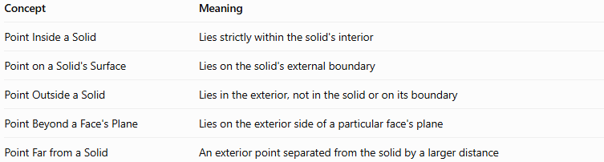
Concept | Meaning
Point Inside a Solid | Lies strictly within the solid's interior
Point on a Solid's Surface | Lies on the solid's external boundary
Point Outside a Solid | Lies in the exterior, not in the solid or on its boundary
Point Beyond a Face's Plane | Lies on the exterior side of a particular face's plane
Point Far from a Solid | An exterior point separated from the solid by a larger distance

Applications
# Source: AI Source: Provided by: [Data Path: Persons Table -> ID Column: 1, Name_En Column: Motasem Essam] -> From: [ChatGPT] on [7/25/2026]
- 3D modeling: Detecting whether an object or point lies outside a modeled solid.
- Computer graphics: Determining visibility, collision, and object positions.
- Engineering: Checking whether a component lies beyond a part's dimensions.
- Architecture: Identifying locations outside rooms and structures.
- Computational geometry: Testing point membership in polyhedra and curved solids.
- Physics: Describing positions external to objects and material volumes.

Key Points
# Source: AI Source: Provided by: [Data Path: Persons Table -> ID Column: 1, Name_En Column: Motasem Essam] -> From: [ChatGPT] on [7/25/2026]
- A point outside a solid lies neither inside the solid nor on its boundary.
- The mathematical conditions depend on the solid's shape and position.
- For a sphere, a squared distance from the center greater than $r^{2}$ indicates an exterior point.
- Being beyond one face's plane does not always establish that a point is outside an arbitrary solid; all relevant constraints must be considered.
- A point outside one component may still lie inside a composite solid.
- The distance from an exterior point to a solid is the shortest distance to any point belonging to that solid.

Conclusion
# Source: AI Source: Provided by: [Data Path: Persons Table -> ID Column: 1, Name_En Column: Motasem Essam] -> From: [ChatGPT] on [7/25/2026]
A point outside a solid is a location in the three-dimensional exterior of a geometric object, excluding both its interior and boundary. It may be near a face, beyond a curved surface, or far from the entire object. Coordinate equations and inequalities provide a systematic way to distinguish exterior points from interior and boundary points.

